# LABORATORY REPORT FORMAT:

Each student will be required to write a formal report after successfully demonstrating a working laboratory project to the instructor. All laboratory reports must be type written on one side of white 8.5” x 11” papers.

The lab report must include the following section:

1. A screen shot of your circuit schematic, symbol, test circuit, simulation of test circuit, layout, and simulation of extracted layout.

2. A print of the input/output waveforms showing the correct operation of circuit

3. You are to submit a color-printed hard copy report.

4. Change the background for your waveforms so yours print out looks clear

5. Avoid adding too many pages in your report. Compactness is key

The report must have these headings:

Title Page**:** The title page must include the course number, the experiment number, the title of the experiment, the date of performing the experiment, the due date, student number, and the name of your partners (if applicable). This should be a separate page.

Objective**:** This section briefly explains the purpose of the experiment.

Theory:This section includes a brief discussion of the theoretical background of the experiment being performed.

Procedure: Please put all the pictures of your work. I am showing for NAND gate.

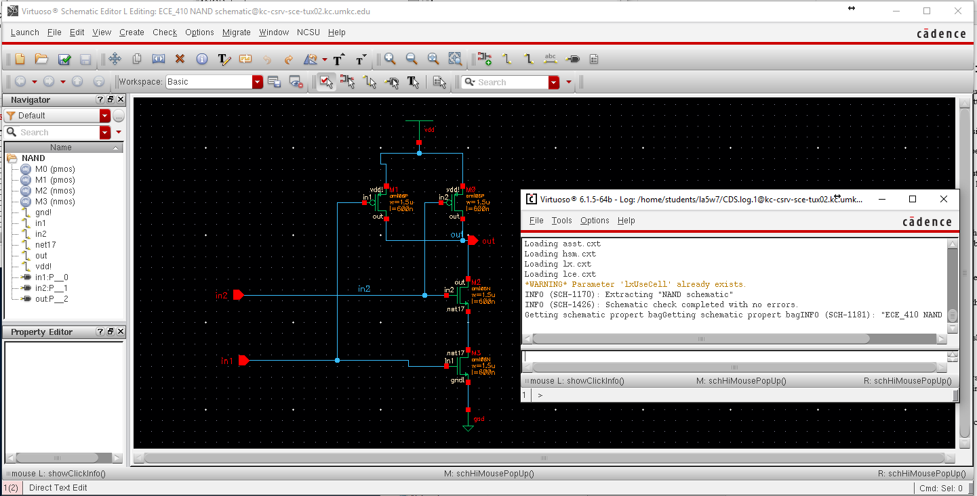

NAND schematic with CIC window

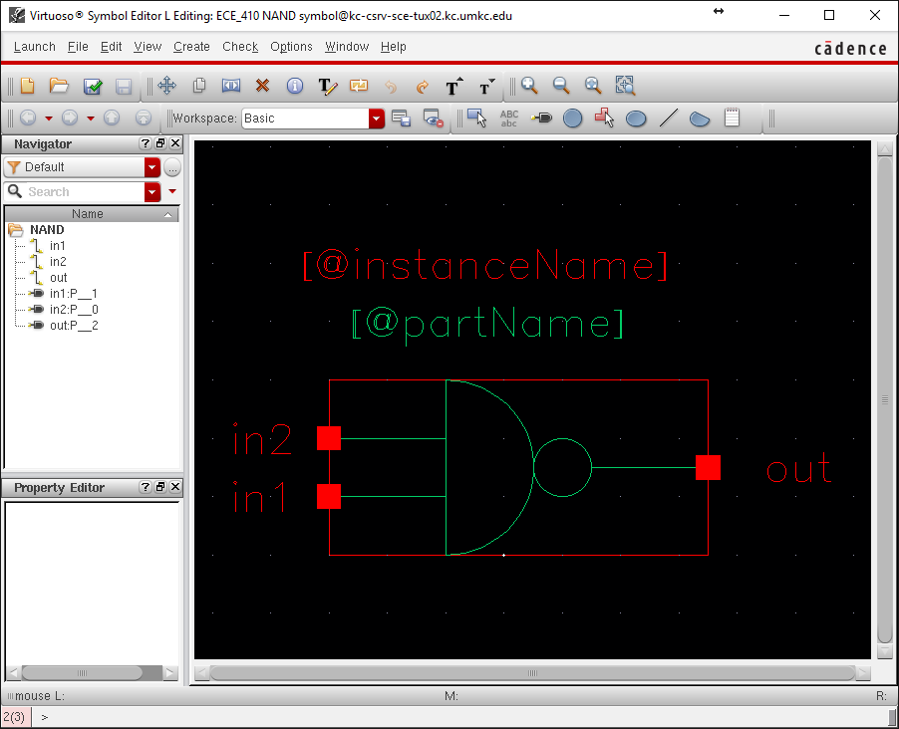

NAND symbol

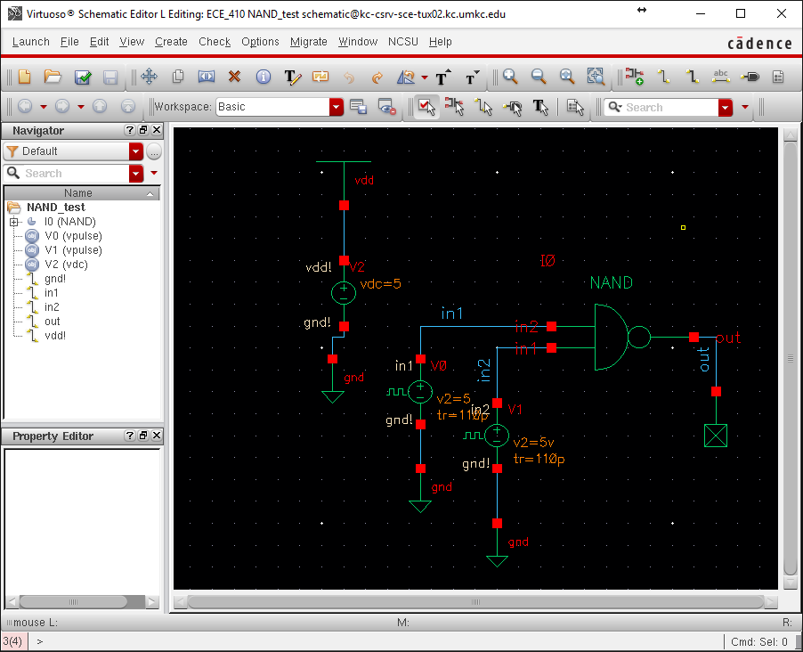

NAND_Test

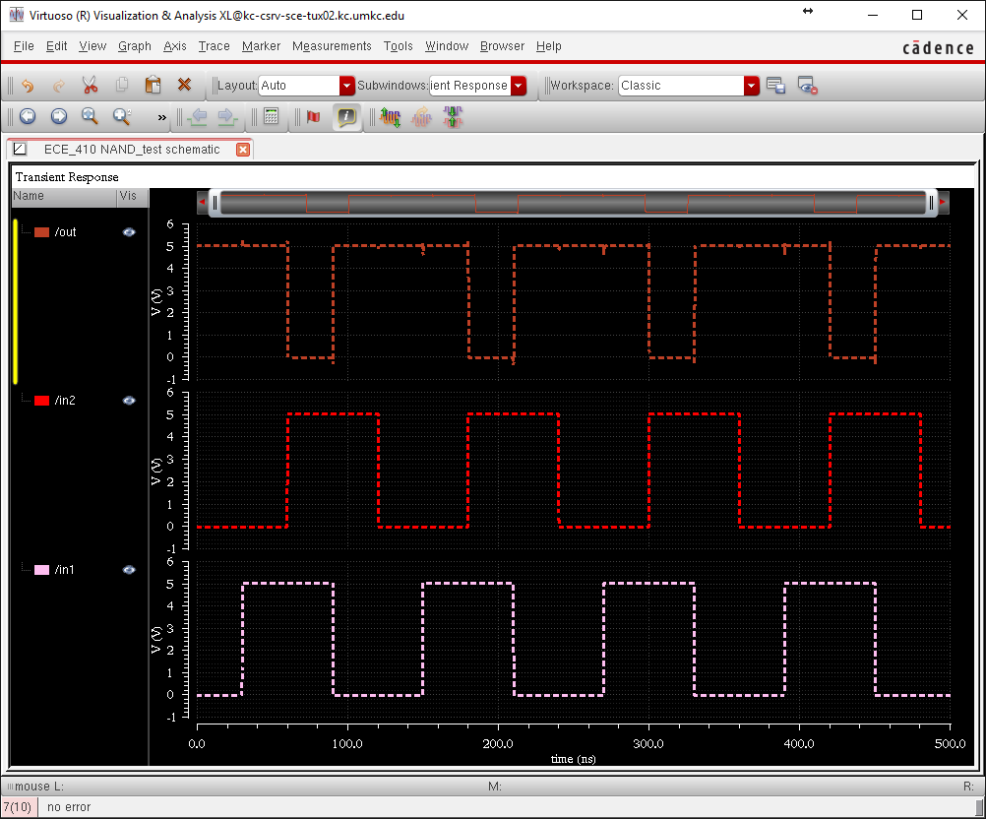

NAND simulation from NAND_Test

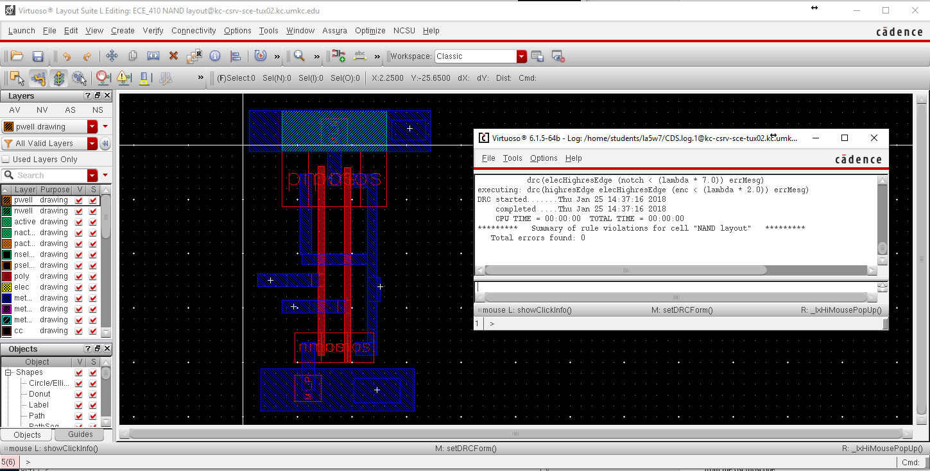

NAND layout and DRC with no errors

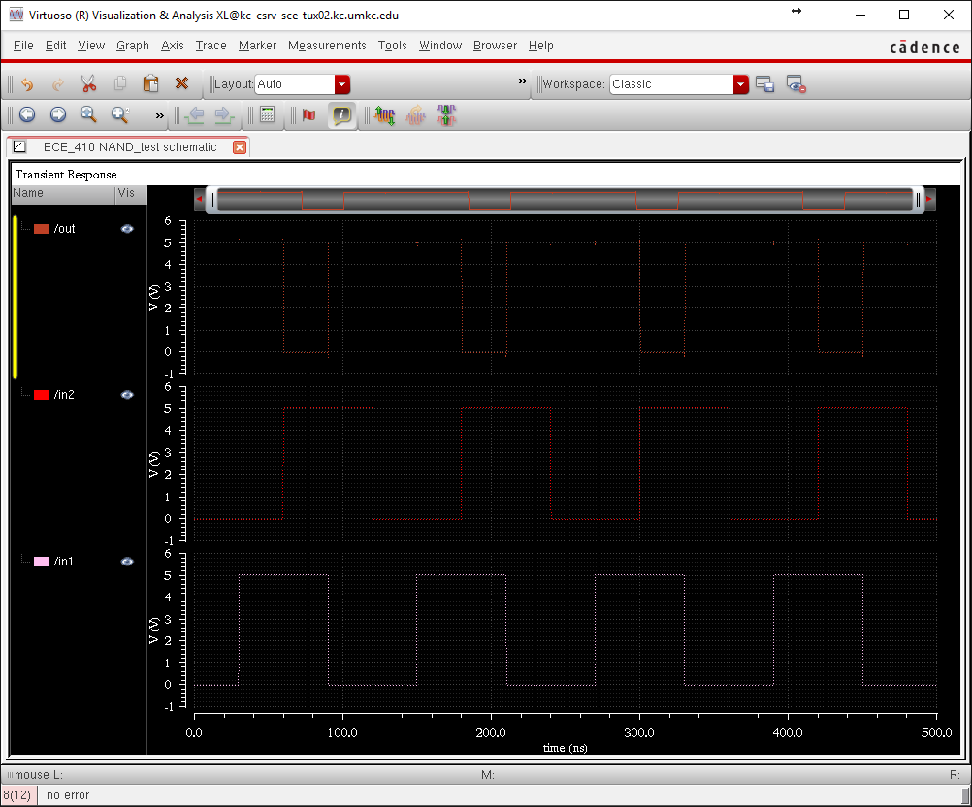

NAND simulation from Extracted layout

Discussion of Results**:** This section includes an analysis of your results obtained from the experiment. Also, include a printout of your result such as the outputs obtained from a program and the waveform obtained from the oscilloscope.

Conclusions: Describe briefly, what you have learned from the experiment.